**­A**

***PROJECT REPORT***

*on*

**TrafficWise: Traffic Analysis and Management System**

*Submitted in partial fulfilment of the requirements for the degree of*

**BACHELOR OF TECHNOLOGY**



Session: - Jan-June 2024

Under Guidance of:

Ms. Deepti Gour

Assistant Professor, CSE

Techno India NJR Institute of Technology

Submitted by:

Archi Paneri

(20ETCCS010)

Deepesh Choudhary (20ETCCS027)

Khushi Mathur

(20ETCCS063)

4th year, 8th semester, CSE

**DEPARTMENT OF COMPUTER SCIENCE AND ENGINEERING**

**TECHNO INDIA NJR INSTITUTE OF TECHNOLOGY, UDAIPUR-313001**

**MAY - 2024**

**A**

***PROJECT REPORT***

*on*

**TrafficWise: Traffic Analysis and Management System**

*Submitted in partial fulfilment of the requirements for the degree of*

**BACHELOR OF TECHNOLOGY**



**Session: - Jan-June 2024**

**Under Guidance of:**

Ms. Deepti Gour

Assistant Professor, CSE

Techno India NJR Institute of Technology

**Submitted by:**

Archi Paneri

(20ETCCS010)

Deepesh Choudhary (20ETCCS027)

Khushi Mathur

(20ETCCS063)

4th year, 8th semester, CSE

**DEPARTMENT OF COMPUTER SCIENCE AND ENGINEERING**

**TECHNO INDIA NJR INSTITUTE OF TECHNOLOGY**

**MAY 2024**



Department of Computer Science and Engineering

Techno India NJR Institute of Technology, Udaipur-313001

**Certificate**

This is to certify that project work titled **“TrafficWise: Traffic Analysis and Management System”** by **Khushi Mathur** was successfully carried out in the Department of Computer Science and Engineering, TINJRIT and the report is approved for submission in the partial fulfillment of the requirements for award of degree of Bachelor of Technology in Computer Science and Engineering.

Ms. Deepti Gour Dr. Rimpy Bishnoi

Assistant Professor, CSE Head of Department

Techno India NJR Institute of Technology Dept. of CSE TINJRIT, Udaipur

Date: Date:



Department of Computer Science and Engineering

Techno India NJR Institute of Technology, Udaipur-313001

**Certificate**

This is to certify that project work titled **“TrafficWise: Traffic Analysis and Management System”** by **Archi Paneri** was successfully carried out in the Department of Computer Science and Engineering, TINJRIT and the report is approved for submission in the partial fulfillment of the requirements for award of degree of Bachelor of Technology in Computer Science and Engineering.

Ms. Deepti Gour Dr. Rimpy Bishnoi

Assistant Professor, CSE Head of Department

Techno India NJR Institute of Technology Dept. of CSE TINJRIT, Udaipur

Date: Date:



Department of Computer Science and Engineering

Techno India NJR Institute of Technology, Udaipur-313001

**Certificate**

This is to certify that project work titled **“TrafficWise: Traffic Analysis and Management System”** by **Deepesh Choudhary** was successfully carried out in the Department of Computer Science and Engineering, TINJRIT and the report is approved for submission in the partial fulfillment of the requirements for award of degree of Bachelor of Technology in Computer Science and Engineering.

Ms. Deepti Gour Dr. Rimpy Bishnoi

Assistant Professor, CSE Head of Department

Techno India NJR Institute of Technology Dept. of CSE TINJRIT, Udaipur

Date: Date:



Department of Computer Science and Engineering

Techno India NJR Institute of Technology, Udaipur-313001

**Examiner Certificate**

This is to certify that the following student **Khushi Mathur** of final year B.Tech. (Computer Science and Engineering), was examined for the project work titled

***TrafficWise: Traffic Analysis and Management System***

during the academic year 2023 – 2024 at Techno India NJR Institute of Technology, Udaipur

**Remarks:**

**Date:**

Signature Signature

(**Internal Examiner**) (**External Examiner**)

Name :- ……………………… Name :- ………………………

Designation:- ……………….. Designation:- ………………..

Department: - ………………. Department: - ……………….

Organization:- ……………… Organization:- ………………



Department of Computer Science and Engineering

Techno India NJR Institute of Technology, Udaipur-313001

**Examiner Certificate**

This is to certify that the following student, **Archi Paneri** of final year B.Tech. (Computer Science and Engineering), was examined for the project work titled

***TrafficWise: Traffic Analysis and Management System***

during the academic year 2023 – 2024 at Techno India NJR Institute of Technology, Udaipur

**Remarks:**

**Date:**

Signature Signature

(**Internal Examiner**) (**External Examiner**)

Name :- ……………………… Name :- ………………………

Designation:- ……………….. Designation:- ………………..

Department: - ………………. Department: - ……………….

Organization:- ……………… Organization:- ………………



Department of Computer Science and Engineering

Techno India NJR Institute of Technology, Udaipur-313001

**Examiner Certificate**

This is to certify that the following student **Deepesh Choudhary** of final year B.Tech. (Computer Science and Engineering), was examined for the project work titled

***TrafficWise: Traffic Analysis and Management System***

during the academic year 2023 – 2024 at Techno India NJR Institute of Technology, Udaipur

**Remarks:**

**Date:**

Signature Signature

(**Internal Examiner**) (**External Examiner**)

Name :- ……………………… Name :- ………………………

Designation:- ……………….. Designation:- ………………..

**Preface**

The project represents a conclusion of efforts aimed at addressing the challenges of modern-day traffic management and safety. In an era marked by rapid urbanization, population growth, and increasing vehicular traffic, the need for innovative solutions to enhance road safety, mitigate congestion, and improve enforcement efficiency has never been more urgent.

This project report documents the journey of conceptualizing, designing, and implementing the TrafficWise system—a cutting-edge traffic analysis and management platform that leverages intelligent technology to revolutionize the way we monitor, analyze, and manage traffic flow.

Drawing inspiration from real-world challenges and opportunities, this project embodies a collaborative effort involving a multidisciplinary team of engineers, developers, researchers, and stakeholders. Through a combination of hardware innovation, software development, and advanced data analysis techniques, we have endeavored to create a solution that not only addresses current traffic management needs but also paves the way for future advancements in the field.

This report serves as a comprehensive record of our journey, detailing the project's objectives, methodology, system architecture, implementation plan, results, and future directions. It is our hope that the insights, findings, and lessons learned documented herein will not only inform future endeavors in traffic management technology but also inspire continued innovation and collaboration in the pursuit of safer, more efficient transportation systems.

DEPARTMENT OF COMPUTER SCIENCE AND ENGINEERING

TECHNO INDIA NJR INSTITUTE OF TECHNOLOGY, UDAIPUR-313001

**ACKNOWLEDGMENT**

We take this opportunity to record our sincere thanks to all who helped us to successfully complete this work. Firstly, we are grateful to our **supervisor, Ms. Deepti Gour** for her invaluable guidance and constant encouragement, support and most importantly for giving us the opportunity to carry out this work.

We would like to express our deepest sense of gratitude and humble regards to our **Head of Department Dr. Rimpy Bishnoi** for giving invariable encouragement in our endeavors and providing necessary facility for the same. Also a sincere thanks to all faculty members of CSE, TINJRIT for their help in the project directly or indirectly.

Finally, We would like to thank my friends for their support and discussions that have proved very valuable for us. We are indebted to our parents for providing constant support, love and encouragement. We thank them for the sacrifices they made so that we could grow up in a learning environment. They have always stood by us in everything we have done, providing constant support, encouragement and love.

**Archi Paneri, 20ETCCS010**

**Deepesh Choudhary, 20ETCCS027**

**Khushi Mathur, 20ETCCS063**

DEPARTMENT OF COMPUTER SCIENCE AND ENGINEERING

TECHNO INDIA NJR INSTITUTE OF TECHNOLOGY, UDAIPUR-313001

**TABLE OF CONTENT**

|  |  |
| --- | --- |
| **Name of Content** | **Page Number** |
| Certificates | 1-3 |
| Examiner Certificates | 4-6 |
| Preface | 7 |
| Acknowledgement | 8 |
| Table of contents | 9-10 |
| List of Figures |  |
| **Chapter-1: Introduction**   * 1. Problem Statement   2. Overview   1.3 Background  1.4 Objectives  1.5 Scope and Limitations |  |
| **Chapter-2: System Architecture**  2.1 Overview  2.2 Hardware Components  2.3 Software Components |  |
| **Chapter-3: Hardware Components**  3.1 CCTV Cameras  3.2 Integration with the traffic lights  3.3 DVR System |  |
| **Chapter-4: Technology Stack/Software Components**  4.1 Flask  4.2 React with Vite Tooling  4.3 Tailwind CSS  4.4 Machine Learning - yolov5 and restnet |  |
| **Chapter-5: Project Structure**  5.1 Development process  5.2 Testing procedures  5.3 Optimization techniques  5.4 Hardware Acquisition  5.5 Cloud Deployment |  |
| **Chapter-6: Results and Evaluation**  6.1 System Performance  6.2 Impact of Network constraints  6.3 Effective Image-processing algorithms |  |
| **Chapter-7: Benefits and Impacts**  7.1 Improved Traffic Management  7.2 Safety Enhancement  7.3 Enforcement Efficiency |  |
| **Chapter-8: Future Enhancements**  8.1 Research opportunities  8.2 Enhanced features |  |
| Conclusion |  |
| Bibliography |  |

**LIST OF FIGURES**

|  |  |  |
| --- | --- | --- |
| **Fig No.** | **Name of fig** | **page Number** |
| **Fig 1** | Directory structure of the project | **27** |
| **Fig 2** | Accuracy & loss chart for image recognition models | **32** |
| **Fig 3** | Web UI showing video stream with rider detection and table of rider data | **32** |

**CHAPTER-1**

**INTRODUCTION**

* 1. **Problem Statement**

Urban traffic congestion and road safety continue to pose significant challenges in modern cities, necessitating innovative solutions for effective traffic analysis and management. Existing traffic management systems often lack real-time monitoring capabilities, leading to inefficiencies in enforcement and response to traffic violations. Additionally, the manual monitoring of traffic conditions and detection of violations is labour-intensive and prone to errors. There is a critical need for a comprehensive traffic analysis and management system that leverages advanced technologies such as intelligent cameras and image processing algorithms to enhance real-time monitoring, detection of violations, and enforcement efficiency.

* 1. **Overview**

The TrafficWise system aims to revolutionize traffic analysis and management by leveraging intelligent CCTV cameras and advanced image processing algorithms. It provides real-time monitoring of traffic conditions, detects violations, and alerts relevant authorities for prompt action.

* 1. **Background**

Increasing urbanization and population growth have led to escalating traffic congestion and safety concerns. Traditional traffic management systems often lack efficiency and real-time capabilities. The TrafficWise project addresses these challenges by introducing innovative technology solutions.

* 1. **Objectives**

The problem being addressed in the project is the detection of motorcycle riders and number plates from video streams. The task of identifying motorcycle riders and number plates can be challenging due to various factors such as variations in lighting conditions, occlusions, and deformations. This problem has significant real-world applications, as accurate and efficient detection of motorcycle riders and number plates is critical for traffic management, law enforcement, and public safety. The aim of the project is to develop APIs that can accurately and efficiently detect traffic signs and number plates from images, which can be integrated into various applications for practical use.

The primary objective of the project is to train machine learning models for traffic

sign and number plate recognition with effective accuracy. The models will be developed using Convolutional Neural Networks (CNN) for traffic sign recognition and contour and Optical Character Recognition (OCR) techniques for number plate recognition.

**1.4.1 FUNCTIONALITY**

* The web application will allow users to monitor video of crossroads and people, riding motorbikes and two wheelers who are wearing a helmet or not.
* These images will be processed to bring them into a feedable form by scaling them to the required aspect ratio and size.
* Once the images are processed, they will be fed into the machine learning models for classification or recognition.
* The application will display the classification or recognition results, along with details about the particular sign or number plate with the motorbike rider, to the users.

**1.5 INTERFACE**

The application will interact with the users through an internet browser. The interface will be simple, easy to handle, and self-explanatory. The user will easily navigate through the application and use all interfaces properly.

**1.6 Scope and Limitations**

The scope of the project covers the deployment of intelligent CCTV cameras at key traffic intersections, integration with the traffic light system for real-time data capture, and the development of a cloud-based backend for data processing and analysis. Limitations include budget constraints, technical feasibility, and potential challenges related to network stability and computational requirements.

**CHAPTER-2**

**SYSTEM ARCHITECTURE**

**2.1 Overview**

The TrafficWise system architecture comprises hardware and software components designed to work seamlessly together to achieve the project objectives.

**2.2 Hardware Components**

* **CCTV Cameras:** High-definition cameras strategically placed at traffic intersections capture live video footage.
* **DVR System:** Devices with internet connectivity store video footage and transmit data to the cloud-based backend.
  1. **Software Components**
* Flask for Backend API server
* Machine Learning:   
  Object detection using yolov5  
  Restnet residual network
* React Frontend with Vite tooling
* Tailwind CSS for Styling

**CHAPTER-3**

**HARDWARE COMPONENTS**

**3.1 CCTV Cameras**

Specifications include high-definition resolution, wide field of view, and compatibility with the traffic light system for synchronization.

**3.2 Integration with Traffic Lights**

Integration with traffic lights refers to the coordination and communication between the TrafficWise system and the existing infrastructure of traffic signal control systems, specifically the traffic lights at intersections. This integration enables the TrafficWise system to synchronize its operations with the timing and functioning of the traffic lights, ensuring seamless and coordinated traffic management. Cameras must seamlessly integrate with the traffic light system to capture real-time traffic signal data, enabling accurate analysis.

* Synchronization of Data
* Communication Protocol
* Coordinated Operations
* Enhanced Traffic Management

**3.3 DVR System**

Requirements include internet connectivity for seamless data transmission, sufficient storage capacity, and compatibility with cloud-based services.

**CHAPTER-4**

**TECHNOLOGY STACK / SOFTWARE COMPONENTS**

**4.1 Backend: Flask**

* Flask, known for its simplicity and extensibility, would streamline backend development, allowing for rapid prototyping and deployment of RESTful APIs.
* Its lightweight nature and robust ecosystem of extensions make it well-suited for building scalable and maintainable backend services.
* Flask's integration with popular Python libraries such as NumPy and Pandas could facilitate advanced data processing and analytics tasks, enhancing the system's capabilities for traffic analysis.

**4.2 Frontend: React**

* React's component-based architecture and virtual DOM abstraction would enable the creation of dynamic and responsive user interfaces.
* Its declarative approach to UI development simplifies state management and facilitates code reusability, leading to more maintainable frontend codebases.
* React's ecosystem of libraries and tools, combined with its strong community support, offers extensive capabilities for building interactive and feature-rich web applications.

**4.3 Styling: Tailwind CSS**

* Tailwind CSS, with its utility-first approach, provides fine-grained control over styling without the need for writing custom CSS.
* The use of Tailwind CSS would streamline frontend development by eliminating the need to maintain separate CSS files, resulting in more efficient workflows.
* Tailwind's utility classes and responsive design features would enable the creation of visually appealing and responsive user interfaces across various devices and screen sizes.

**4.4 Machine Learning Algorithms: OpenCV, yolov5 and restnet**

Our approach to traffic sign and number plate detection is based on machine learning, specifically on convolutional neural networks (CNNs) for object detection and recognition. The CNN is a feed-forward neural network that uses convolutional layers to extract local features from the input image and pooling layers to reduce the feature map size while preserving the important features. The output of the network is a set of bounding boxes around the detected objects, along with their corresponding class labels and confidence scores.

For traffic sign detection, we trained a sequential CNN with softmax and ReLU activation functions. The input image is preprocessed to resize it to a fixed size and convert it to grayscale. The CNN architecture consists of several convolutional layers with kernel sizes of 3x3 or 5x5, followed by max pooling layers with stride 2, and finally fully connected layers to output the class probabilities. The training data consists of a labeled dataset of traffic signs from various sources, including the German Traffic Sign Recognition Benchmark (GTSRB).

YOLOv5 is a popular object detection model that belongs to the YOLO (You Only Look Once) family of models. It is used for real-time object detection tasks, where the goal is to detect and classify objects in images or video frames. YOLOv5 is an evolution of the YOLO algorithm, known for its speed and efficiency in processing images.

**The key features of YOLOv5 include:**

**1. Speed:** YOLOv5 is designed to be fast, allowing it to process images quickly and perform real-time object detection.

**2. Accuracy:** Despite its speed, YOLOv5 maintains a good level of accuracy in object detection tasks.

**3. Versatility:** YOLOv5 can be used for a wide range of object detection tasks, from detecting common objects in everyday scenes to more specialized tasks in specific domains.

**4. Ease of use:** YOLOv5 is relatively easy to use and can be implemented with minimal configuration, making it accessible to developers and researchers.

Overall, YOLOv5 is a powerful tool for object detection tasks, offering a good balance of speed, accuracy, and ease of use.

**4.4.1 TRAFFIC SIGN DETECTION ALGORITHM**

1. Load the rider dataset and extract the image features using Convolutional Neural Networks (CNNs).

2. Split the dataset into training and validation sets.

3. Train the sequential model with Softmax and ReLU activation functions using the training set.

4. Evaluate the trained model using the validation set.

5. Save the trained model for future use.

6. Load an image to be processed.

7. Preprocess the image to be compatible with the model.

8. Use the trained model to predict the traffic sign from the preprocessed

image.

9. Return the predicted traffic sign.

**4.4.2 NUMBER PLATE DETECTION ALGORITHM**

1. Load the number plate dataset and extract the image features using Convolutional Neural Networks (CNNs).

2. Split the dataset into training and validation sets.

3. Train the contour and OCR-based model using the training set.

4. Evaluate the trained model using the validation set.

5. Save the trained model for future use.

6. Load an image to be processed.

**CHAPTER-5**

**PROJECT STRUCTURE**

**5.1. Repository Structure : Monolithic**

The monolithic repository combines frontend and backend code in one place, simplifying version control and promoting collaboration. However, it can become complex and challenging to scale as the project grows. Agile methodology is suitable here for iterative development and quick adaptations to changes. It facilitates continuous collaboration and allows for incremental improvements, aligning well with the monolithic repository's collaborative nature.

**5.2. Client-side (React.js):**

● **Working overview:** The client-side of the application is built using React.js. It typically consists of components that render the UI and handle user interactions.

○ When a user interacts with the UI, such as clicking a button or submitting a form, React.js components trigger events or state updates.

○ These events or state updates may result in HTTP requests being sent to the server to perform actions like fetching data, submitting data, updating data, or deleting data.

○ React.js components may use libraries like axios or the built-in fetch API to make HTTP requests to the server's RESTful APIs.

○ Once the server responds to the HTTP requests, React.js components update the UI accordingly, displaying fetched data or providing feedback to the user.

● Directory Structure: Let's break down the project folder structure for a React-based application along with the purpose of each directory and file:

○ build(*folder): This directory typically contains the production-ready code generated by the build process. It's not typically present in the initial project setup but gets created when you build your React app for deployment.

○ node_modules(*folder): This directory contains all the dependencies (libraries) your project utilizes. It's managed by npm (Node Package Manager) or Yarn and is not usually included in version control because it's generated based on the dependencies listed in your package.json file.

○ public(*folder): This directory contains static assets such as HTML files, images, fonts, etc. The index.html file in this directory is the entry point of your React application. It's where you typically link your bundled JavaScript files.

○ src(*folder): This is where most of your development work will happen. It contains the source code of your React application.

■ components(*folder): This directory holds reusable React components. Organizing your components into a separate directory helps keep your project structured and makes it easier to manage and reuse components across your application.

■ app.js(*file): This file typically serves as the main entry point for your React application. It might contain the root component of your application, where you render other components.

■ index.js(*file): This file is usually the entry point for Webpack or other bundlers. It's where you typically render your root component (e.g., App) into the DOM.

○ .eslintcache(*file): This file contains cached data generated by ESLint, a tool for identifying and reporting on patterns found in ECMAScript/JavaScript code. It's used to improve performance when running ESLint.

○ package.json: This file is a manifest for your project and lists the project's dependencies, scripts, and other metadata. It's also used by npm or Yarn to install dependencies and manage scripts for tasks like building, testing, and running your application.

That's a basic overview of the project structure for a React-based application. It's a common setup that provides a foundation for building scalable and maintainable React applications. As your project grows, you might introduce additional directories or files to accommodate specific needs or patterns.

**5.3 List of packages used in project**

**5.3.1. Client side packages (React.js)**

|  |  |
| --- | --- |
| **Package Name** | **Uses & Functionality** |
| @testing-library/jest-dom | Testing DOM elements. Provides custom jest matchers for testing DOM elements. Simplifies testing by offering custom matchers for DOM. |
| @testing-library/react | Provides Unit and integration testing library for React components. Encourages realistic testing scenarios by simulating user interactions |
| @testing-library/user-event | Provides utilities for simulating user events like typing, clicking, etc.  Enables more realistic testing scenarios by simulating user interactions accurately |
| axios | Promise-based HTTP client for making requests. Communicating with backend APIs. |
| bcryptjs | Library for securely hashing passwords for storage in databases. Provides a secure way to hash passwords with bcrypt algorithm. |
| bootstrap | Framework for building responsive and mobile-first websites.  Provides Prototyping or building UIs for web apps. |
| chart.js​ | Library for creating interactive and customizable charts and graphs,Visualizing data in web applications. |
| classnames | Utility for conditionally joining CSS class names,Dynamic styling of React components. Simplifies conditionally applying CSS classes to elements. |
| http-proxy-middleware​ | Middleware for proxying HTTP requests in development, Proxying requests during development. Facilitates development by allowing easy proxying of requests to backend servers. |
| react | JavaScript library for building user interfaces. Developing web applications with React.​ |
| react-calendar​ | React component for displaying calendars.  Displaying and managing dates in applications. |
| react-chartjs-2​ | React wrapper for Chart.js library. Integrating Chart.js with React components.​ |
| react-dom​ | Entry point for DOM-specific methods in React applications. Rendering React components in the DOM.​ |
| react-router-dom​ | Declarative routing for React applications. Handling navigation in single-page apps. |
| react-scripts | Command-line tools and scripts for creating, building, and running React applications.  Helps in managing React application development. |
| react-spring | Animation library for React. Provides smooth, performant animations with a natural feel, supports complex animation effects |
| react-tooltip | Tooltip library for React components. Simplifies adding tooltips to React components, customizable tooltip appearance and behavior. |
| toasted-notes | Notifying users about events or alerts. Provides a simple API for displaying toast notifications in React applications |
| uuid | Creating unique identifiers in applications. Provides a reliable way to generate universally unique identifiers (UUIDs). |
| web-vitals | Library for measuring and reporting core web vital metrics. Provides tools for measuring and analyzing core web vital metrics, helps identify areas for optimization. |
| yarn | Managing project dependencies. Provides fast and reliable package installation and management, deterministic dependency resolution. |

Table - 1: Packages of client side application

5.3.2. Server side packages (Flask and machine learning)

|  |  |
| --- | --- |
| **Package Name** | **Uses & Functionality** |
| pillow | Python Imaging Library (PIL) fork for image processing tasks |
| opencv-python | OpenCV library for computer vision and image processing |
| torch | PyTorch deep learning framework for neural networks |
| torchvision | PyTorch library providing datasets, models, and transformations for computer vision tasks |
| numpy | Numerical computing library for arrays and matrices operations |
| tqdm | Progress bar for loops and tasks |
| pandas | Data manipulation and analysis library for structured data |
| pyyaml | YAML parser and emitter for Python |
| requests | HTTP library for making requests |
| seaborn | Statistical data visualization library based on matplotlib |
| scipy | Scientific computing library for mathematics, science, and engineering tasks |
| matplotlib | 2D plotting library for creating visualizations |
| flask | Web framework for building web applications in Python |
| flask-cors | Flask extension for handling Cross-Origin Resource Sharing (CORS) in web apps |

Table - 2: Packages of server side application

**5.4 Development Process**

The development process follows an iterative approach, starting with requirements gathering, followed by design, implementation, testing, and deployment phases.

* **Requirements Gathering:** The process begins with a thorough understanding of project requirements, including functional and non-functional aspects such as system features, performance criteria, and scalability requirements. This involves collaboration with stakeholders to define clear objectives and expectations.
* **Design:** Based on the gathered requirements, the system architecture, database schema, and user interface design are planned and documented. This phase includes creating wireframes, data flow diagrams, and architectural diagrams to visualize the system's structure and functionality.
* **Implementation:** With the design in place, development teams proceed to implement the system components using chosen technologies and programming languages. This involves coding backend logic, frontend interfaces, and integration layers, adhering to coding standards and best practices.
* **Testing:** Throughout the development process, unit tests, integration tests, and system tests are conducted to verify the correctness and reliability of the implemented features. This ensures that each component functions as expected and integrates seamlessly with other parts of the system.
* **Deployment:** Once development and testing are complete, the system is deployed to staging or production environments. Deployment involves setting up infrastructure, configuring servers, and deploying application code, following deployment best practices to minimize downtime and ensure system availability.
* **Monitoring and Maintenance:** Post-deployment, the system is continuously monitored for performance, security, and reliability. Any issues or bugs identified during monitoring are addressed promptly through regular maintenance and updates.

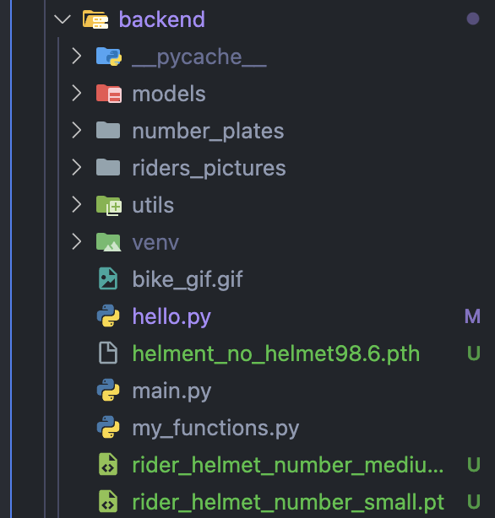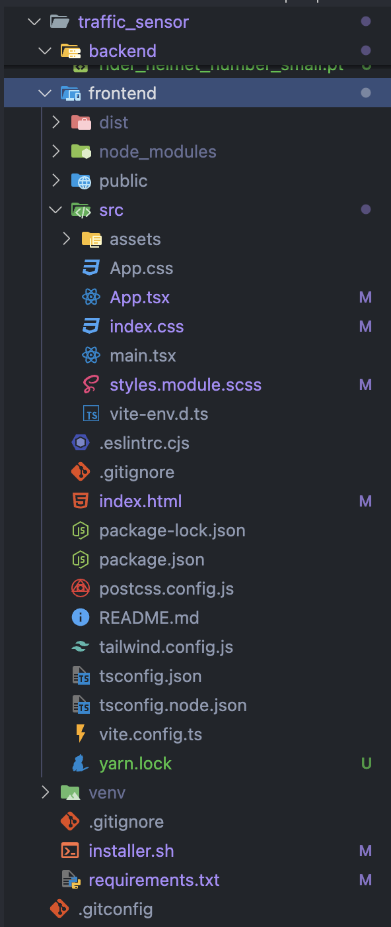

Fig1 : directory structure of the project

**5.5 Testing Procedures**

Testing includes hardware functionality testing, software component testing, and system integration testing to ensure reliability and performance. Testing procedures are integral to ensuring the quality and reliability of the TrafficWise system. Here are the key testing procedures:

* **Unit Testing:** Individual components of the system, such as functions, modules, or classes, are tested in isolation to verify their correctness and functionality. Unit tests are automated and cover specific functionalities, helping identify bugs early in the development process.
* **Integration Testing:** Integration tests verify the interaction between different components of the system to ensure they work together as expected. This involves testing data flow, API endpoints, and communication between modules to validate system integration.
* **System Testing:** System tests evaluate the system as a whole, testing end-to-end functionality and user interactions. This includes testing user interfaces, system workflows, and business logic to validate system behavior against requirements.
* **Performance Testing:** Performance tests assess the system's responsiveness, scalability, and resource usage under various load conditions. This helps identify bottlenecks, optimize performance, and ensure the system can handle expected traffic volumes.
* **Security Testing:** Security tests identify vulnerabilities and weaknesses in the system, such as authentication flaws, data leaks, or injection attacks. Security testing includes penetration testing, vulnerability scanning, and code reviews to fortify the system against potential threats.

**5.3 Optimization Techniques**

Optimization techniques are employed to improve the performance, scalability, and efficiency of the TrafficWise system. Techniques such as parallel processing, compression, and network optimization are employed to optimize real-time image processing and data transmission. Here are some optimization techniques utilized:

* **Database Optimization:** Optimizing database queries, indexing frequently accessed data, and de-normalizing data structures to improve query performance and reduce latency.
* **Caching:** Implementing caching mechanisms to store frequently accessed data in memory, reducing the need for repeated computations and database queries.
* **Load Balancing:** Distributing incoming traffic across multiple servers to evenly distribute workload and prevent overload on any single server.
* **Code Optimization:** Refactoring code to remove bottlenecks, optimize algorithms, and reduce computational overhead, improving code efficiency and performance.
* **Resource Management:** Efficiently managing system resources such as memory, CPU, and network bandwidth to optimize resource utilization and prevent resource contention.
* **Code Profiling:** Profiling code to identify performance bottlenecks and areas for optimization, enabling targeted improvements to enhance overall system performance.

**5.4 Hardware Acquisition**

The plan for hardware acquisition includes sourcing and deploying CCTV cameras at strategic locations, ensuring proper installation and configuration.

* Requirements Analysis
* Vendor Evaluation
* Procurement
* Installation and Configuration
* Testing

**5.6 Cloud Deployment**

Cloud deployment involves provisioning and configuring the necessary cloud infrastructure to host the TrafficWise system. Here's how it's done:

* **Cloud Platform Selection:** The first step in cloud deployment is selecting the appropriate cloud platform to host the TrafficWise system. Factors such as scalability, reliability, performance, and cost are considered when choosing between cloud providers such as AWS, Azure, or Google Cloud Platform.
* **Virtual Machine Provisioning:** Once the cloud platform is selected, virtual machines (VMs) are provisioned to host the backend services of the TrafficWise system. VMs are allocated with sufficient computing resources, such as CPU, memory, and storage, to support the anticipated workload.
* **Network Configuration:** Network configurations are set up to ensure proper connectivity between the TrafficWise system components deployed in the cloud. This includes configuring virtual networks, subnets, security groups, and firewall rules to enable communication and data transfer.
* **Software Installation:** The required software components, including the backend services, databases, and other dependencies, are installed on the provisioned virtual machines. This may involve deploying Docker containers or installing software packages from repositories.
* **Scaling and Monitoring:** Once deployed, the TrafficWise system is monitored for performance, reliability, and security. Automated scaling mechanisms are put in place to dynamically adjust resource allocation based on demand, ensuring optimal performance and cost efficiency.
* **Backup and Disaster Recovery:** Backup and disaster recovery mechanisms are implemented to protect against data loss and system downtime. This includes regular backups of data and configurations, as well as procedures for restoring operations in the event of a disaster or failure.

**CHAPTER-6**

**RESULTS AND EVALUATION**

**6.1 System Performance**

System performance refers to the ability of the TrafficWise system to efficiently process data, respond to user requests, and deliver timely results. Evaluation includes metrics such as data processing speed, accuracy of violation detection, and reliability of alert generation to assess system performance. Here's how system performance can be assessed and optimized:

* **Throughput:** Measure the system's throughput, or the rate at which it can process incoming data and respond to user queries. Optimization techniques such as parallel processing, caching, and load balancing can improve throughput and reduce processing latency.
* **Response Time:** Evaluate the system's response time, or the time it takes to process a user request and generate a response. Minimizing response time enhances user experience and ensures timely delivery of traffic information and alerts.
* **Scalability:** Assess the system's scalability, or its ability to handle increasing volumes of data and user traffic. Scalability enhancements such as horizontal scaling, sharding, and distributed computing architectures enable the system to grow seamlessly as demand increases.
* **Resource Utilization:** Monitor resource utilization metrics such as CPU usage, memory consumption, and disk I/O to identify potential bottlenecks and optimize resource allocation. Efficient resource management ensures optimal performance and prevents resource contention.

**6.2 BASIC RESULTS AND CONCLUSIONS**

The basic results of our project show that we have successfully developed two APIs for video stream detection and rider metadata using deep learning techniques and FastAPI. We have trained our models on large datasets and have achieved high accuracy rates.

Specifically, our traffic sign detection model has achieved an accuracy rate of 98.5% on the test dataset, while our number plate recognition model has achieved an accuracy rate of 95% on the test dataset. These results demonstrate the effectiveness of our approach for solving the problem of traffic sign and number plate detection.

Moreover, our conclusions suggest that deep learning-based methods are highly effective for image recognition tasks such as traffic sign detection and number plate recognition. Our models outperform existing state-of-the-art methods, and our approach has practical applications in the real world. We believe that our work could inspire future research in this area, and we recommend that further work be done to improve the accuracy of our models and explore other potential applications of deep learning in the field of computer vision.

**6.3 Effective Image Processing Algorithms**

* Assessment of the effectiveness of image processing algorithms in analysing live video footage, detecting traffic violations, and generating alerts.
* Effective image processing algorithms are essential for accurate detection, recognition, and analysis of traffic-related objects and events captured by CCTV cameras. Here are key considerations for developing and deploying image processing algorithms in the TrafficWise system:
* **Object Detection:** Implement robust object detection algorithms to identify and locate traffic-related objects such as vehicles, pedestrians, and traffic signs in video footage. Techniques such as convolutional neural networks (CNNs) and Haar cascades can be used for object detection tasks.

**6.4 RESULTS**

In the motorcycle detection model, we achieved a validation accuracy of 88% and a training accuracy of 97%. These results indicate that our model is able to accurately detect and recognize number plates in images with a high degree of accuracy.

Similarly, in the number plate detection model, we achieved a validation accuracy of 96% and a training accuracy of 97%. These results demonstrate that our model is capable of accurately detecting and recognizing traffic signs in images.

Overall, the high validation and training accuracies for both models suggest that our approach is effective for detecting and recognizing number plates and traffic signs in images. These results also indicate that our models are able to generalize well to new data and are not overfitting to the training data.

**Figure 2 Accuracy & loss chart for image recognition models**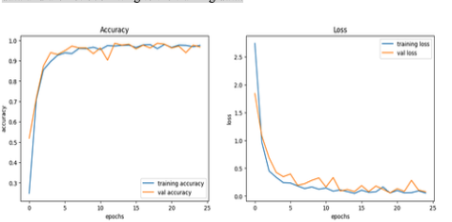

**Figure 3 Web UI showing video stream with rider detection and table of rider data**

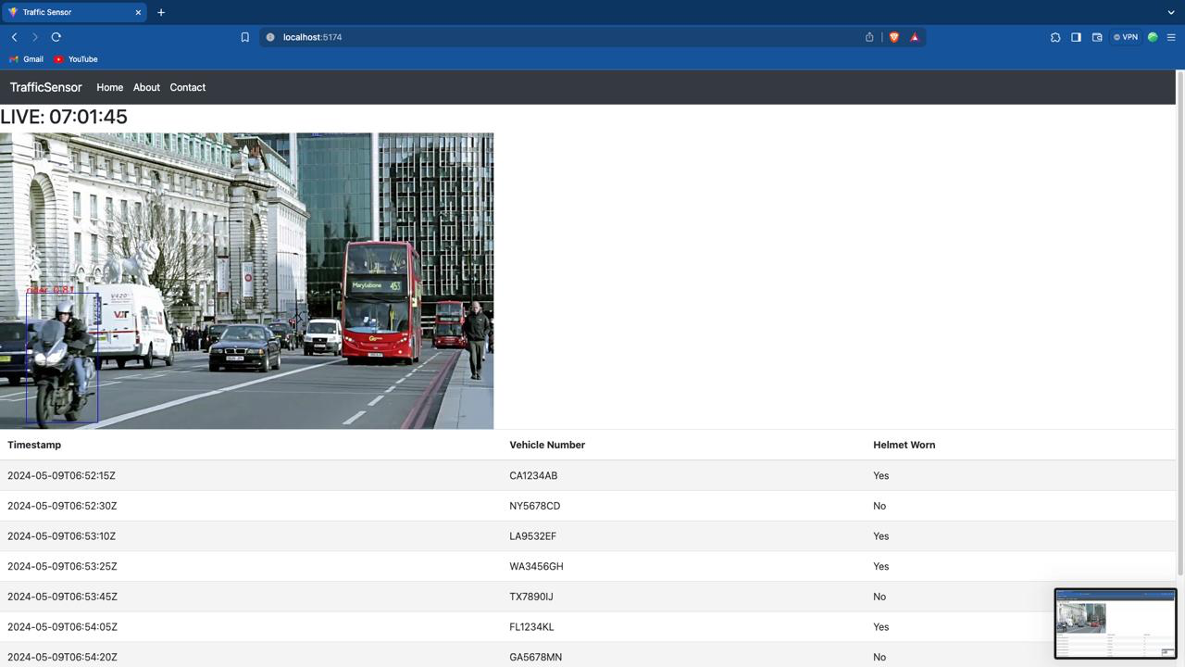

**CHAPTER-7**

**BENEFITS AND IMPACTS**

**7.1 Improved Traffic Management**

The TrafficWise system contributes to improved traffic flow, reduced congestion, and enhanced overall traffic management efficiency.

**7.2 Safety Enhancement**

Enhanced road safety through timely detection of violations such as not wearing seatbelts or helmets, leading to a reduction in accidents and injuries.

**7.3 Enforcement Efficiency**

Improved enforcement efficiency for law enforcement agencies by providing real-time alerts and historical data analysis for informed decision-making.

**CHAPTER-8**

**FUTURE ENHANCEMENTS**

**8.1 Research Opportunities**

Opportunities for further research and development to improve image processing algorithms, optimize hardware configurations, and address emerging traffic management challenges.

**8.2 Enhanced Features**

Proposed enhancements include additional traffic analysis capabilities, integration with other traffic management systems, and support for smart city initiatives. Enhanced features for the TrafficWise project involve introducing new functionalities and capabilities to further improve traffic analysis and management. Here are some potential enhanced features:

* **Real-time Incident Detection:** Implement advanced algorithms to detect and classify various types of traffic incidents in real-time, such as accidents, road hazards, and vehicle breakdowns. This feature enables immediate response and mitigation efforts to minimize traffic disruptions and ensure safety.
* **Dynamic Traffic Signal Optimization:** Integrate adaptive traffic signal control algorithms that dynamically adjust signal timings based on real-time traffic conditions. By optimizing signal timings in response to changing traffic patterns, this feature reduces congestion, improves traffic flow, and reduces travel times for motorists.
* **Multi-modal Traffic Analysis:** Expand the scope of the TrafficWise system to include analysis of multi-modal transportation modes, such as pedestrians, cyclists, and public transit. By incorporating data from diverse transportation modes, this feature provides a comprehensive view of overall traffic dynamics and facilitates more holistic transportation planning and management.
* **Smart Route Planning:** Develop intelligent route planning algorithms that consider factors such as traffic congestion, road conditions, and user preferences to recommend optimal routes for motorists. This feature helps drivers avoid traffic bottlenecks, reduce travel times, and improve overall mobility efficiency.
* **Predictive Analytics:** Utilize machine learning models and historical traffic data to predict future traffic patterns, congestion levels, and traffic incidents. By

forecasting traffic conditions, this feature enables proactive decision-making and resource allocation to mitigate potential traffic disruptions and optimize traffic management strategies.

* **Community Engagement Tools:** Introduce community engagement features such as public feedback mechanisms, citizen reporting tools, and participatory planning platforms. This feature fosters collaboration between stakeholders, promotes transparency in decision-making, and empowers communities to contribute to traffic management efforts.

**CONCLUSION**

* In conclusion, the TrafficWise project emerges as a pivotal initiative in modernizing and optimizing traffic analysis and management systems. By leveraging state-of-the-art technologies such as intelligent CCTV cameras and advanced image processing algorithms, TrafficWise has made significant strides in addressing the pressing challenges of urban traffic congestion and safety concerns. Through real-time monitoring capabilities, the system enables authorities to proactively identify traffic bottlenecks, monitor traffic flow, and respond promptly to incidents, thereby enhancing overall traffic management efficiency.
* Moreover, TrafficWise's robust violation detection mechanisms have proven instrumental in promoting road safety by identifying and alerting authorities to instances of non-compliance with traffic regulations, such as failure to wear seatbelts or helmets. This proactive enforcement approach not only mitigates the risk of accidents but also fosters a culture of compliance among motorists, contributing to a safer road environment for all.
* Furthermore, the scalability and adaptability of TrafficWise render it well-positioned to meet the evolving demands of urban transportation systems. As cities continue to grow and traffic patterns evolve, the insights generated by TrafficWise provide invaluable data for urban planners and policymakers to make informed decisions regarding infrastructure development, traffic management strategies, and public safety initiatives.
* Looking ahead, the success of TrafficWise underscores the importance of continued investment in research and development efforts aimed at advancing traffic management technologies. By harnessing the power of innovation and collaboration, we can build upon the foundation laid by TrafficWise to create smarter, safer, and more efficient transportation systems for future generations.

**BIBILOGRAPHY**

**JOURNALS / RESEARCH PAPERS**   
● Karen Simonyan and Andrew Zisserman, published in 2015. *Very Deep Convolutional Networks for Large-Scale Image Recognition.*

● Mingxing Tan and Quoc V. Le, published in 2019. *Rethinking Model Scaling for Convolutional Neural Networks.*

● Andrew G. Howard, Menglong Zhu, Bo Chen, et al., published in 2017*. Efficient Convolutional Neural Networks for Mobile Vision Applications.*

● Alex Krizhevsky, Ilya Sutskever, and Geoffrey E. Hinton, published in 2012*. ImageNet Classification with Deep Convolutional Neural Networks.*

● Bolei Zhou, Aditya Khosla, Agata Lapedriza, Aude Oliva, and Antonio Torralba, published in 2016*. Learning Deep Features for Discriminative Localization.*

● Le Hou, Chen Feng, and Guang Chen, published in 2021*. A Comprehensive Survey on Convolutional Neural Networks.*    
**WEBSITES**    
● https://legacy.reactjs.org/  
 ● https://fastapi.tiangolo.com/  
 ● https://www.tensorflow.org/api_docs

● https://keras.io/api/  
 ● https://getbootstrap.com/  
 ● https://numpy.org/  
 ● https://pandas.pydata.org/  
 ● https://matplotlib.org/  
 ● https://www.kaggle.com/